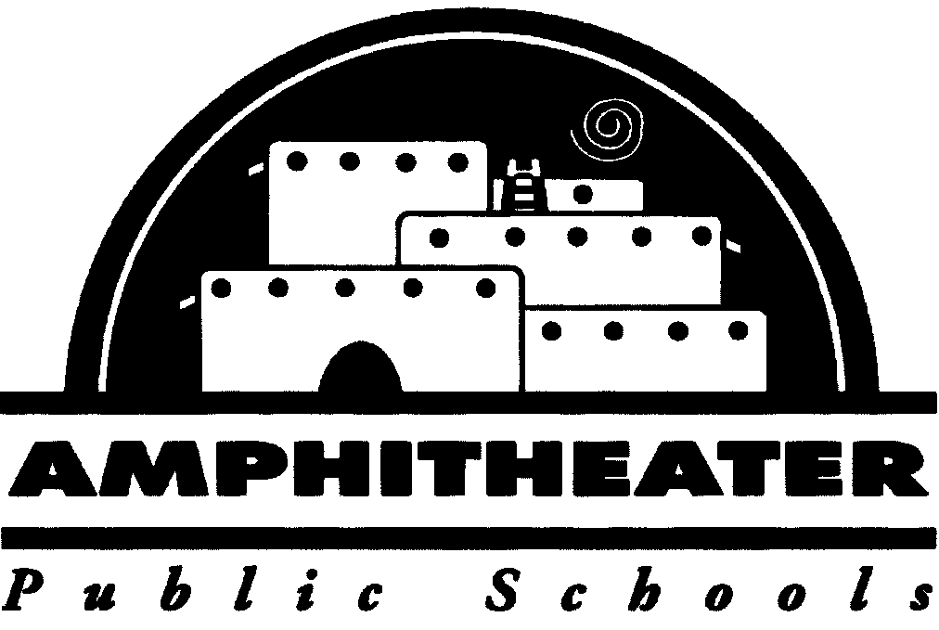

**Amphitheater Public Schools**

**Amphitheater On Campus Supervision**

Governor Ducey’s Executive Order 2020-51 requires our district to provide supervision for students “…who need a place to go during the day…”. Parents who require this service must complete this form and return it to the school where their child is enrolled.

Requesting Supervision Services for the Week of: ______

Student Name (print): ______

School: ______

Grade Level: ______

Address: ______

Parents’ Names (print): ______

Parents’ Phone Numbers: ______

Emergency Contact Name: ______

Emergency Contact Phone Number: ______

Why does your child need this service?: (choose one or more)

___ Special Education Student ___ In Foster Care ___ No Internet Access at Home

___ Parents are First Responders ___ McKinney-Vento ___ Child Care Issues

___ English Language Learner

I have read and understand the Terms and Conditions for this service and agree to adhere to these rules.

Parent Signature: _____________________________________________________________

Parent Name (print): ______

Date: ______